**HW3 MOVES**

1. Estimate CO2 emission rates in g/mile for passenger cars using MOVES under different speeds
   1. I estimated the operating mode distribution for running exhaust process for passenger cars on an urban unrestricted link for four average speeds (15, 35, 55, and 75 mph) using MOVES. The operating mode distribution is the fraction of time that vehicles spend at different operating modes.

The passenger car operating mode distributions by the four different vehicle average speed are in the attached text file:

* hw3_opmodedistribution.csv

The MOVES energy rates (kJ for model year 2022 vehicles attached in the files

* energyrate_opmode_cars.csv

MOVES calculates CO2 emissions for gasoline vehicles from energy using the following equation and conversion factors:

$$grams CO_{2}=KJ gasoline ×\left(\frac{0.0196 grams Carbon}{KJ gasoline}\right)×\frac{44 grams CO_{2}}{12 grams C}$$

Calculate the average CO2 g/mile emission rates for model year 2022 passenger car for each of the four average speeds.

|  |  |  |  |  |
| --- | --- | --- | --- | --- |
| Speed | 15 | 35 | 55 | 75 |
| KJ/hour | 64075 | 96671 | 137313 | 204414 |
| g CO2/hr | 4605 | 6947 | 9868 | 14691 |
| g CO2/mile | 307 | 198 | 179 | 196 |

20 pts

* 1. Does the relationship between CO2 emission rates in g/mile and vehicle speed make sense? Explain. For example, why does the CO2 g/mile increase at low speeds, and again at high speeds?

Increase at high speed. 5 pts

CO2 g/mile emissions increase at high speeds due to increase aerodynamic drag at high speeds. For example, below is shown the aerodynamic energy demand per km needed to overcome aerodynamic drag and rolling resistance at a constant speed for our hypothetical example of a Ford Explorer. We can The energy to overcome rolling resistance and rotational resistance can also increase with speed.

Increase at low speed. 5 pts

There are two reasons why emissions increase at low speed

* ICE Engines are more efficient (fuel consumption/work) at high power. Because of the improved work efficiency at higher loads, the vehicle has a better fuel economy at moderate speeds (even though the engine is consuming more fuel per second at higher loads).

A. Elgowainy, Ed., Electric, Hybrid, and Fuel Cell Vehicles. New York, NY: Springer New York, 2021. doi: 10.1007/978-1-0716-1492-1.

This impact is shown with data below. At constant speeds, a midsize conventional gasoline vehicle will have a better gas mileage around ~ 55mph.

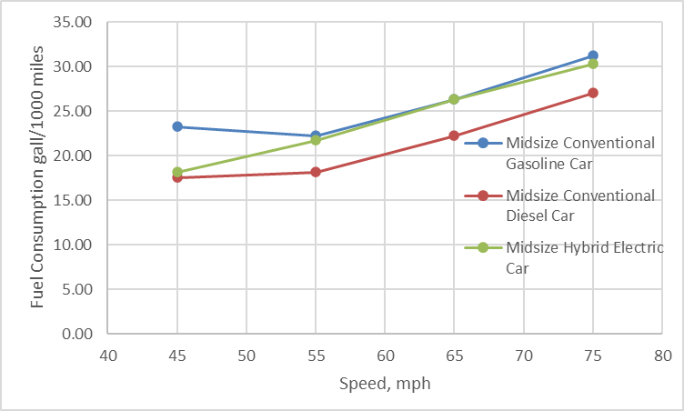

Data from: Oak Ridge National Laboratory, Transportation Energy Data Book #39, Table 4.33. tedb.ornl.gov

* The second, and likely more important, important reason is acceleration causes an additional load to the vehicle, and in typical driving conditions, there is more vehicle acceleration and deceleration at low average speeds.
 $$P_{V}=\frac{1}{2}ρ_{a}C_{D}A_{v}v^{3}+v\left(C_{R}m_{v}g +m_{v}g\sin{α}+m_{v}a_{v}\right)$$

 + In typical driving conditions, at lower average speeds, we are not traveling at constant speeds, but are frequently decelerating and accelerating at stop signs, traffic lights, and due to traffic congestion. MOVES driving cycle are based on representative driving, and the low speeds drive cycles incorporate more deceleration and acceleration at lower speeds than higher speeds. On the other and, higher speed drive cycles include more free flow driving conditions.

10 pts

* 1. Estimate the fleet-average (all model year) passenger car CO2 g/mile emission rates for four average speeds (15, 35, 55, and 75) on an urban restricted access road using MOVES.

Run MOVES with the following information:

Scale: Project Scale, Inventory

Calendar Year: 2022

Pollutants and Processes: Atmospheric CO2 (running exhaust only)

Road Type: Urban Unrestricted Access

Create an Input Database with the four links with the average speed specified above (15, 35, 55, and 75)

General output: Select “Distance Traveled” in the Activity Output

For other inputs select you inputs of your own choice.

Calculate the average emission rate for each speed, using the total CO2 and total miles by linkID.

To access the output from your test run, you can use the Post Processing tab. ‘Run SQL Script on Onroad Output Database’ -> Select output processing script -> ‘Tabbed Output.sql.’ That will output the results to a txt file that you can analyze with another software.

I have also provided my example R script, if you want to export the data into R from the SQL database.

|  |  |  |  |  |  |  |  |
| --- | --- | --- | --- | --- | --- | --- | --- |
| linkID | linkavgspeed | linklength | linkvolume | pollutantID | sum_emission (grams) | Vehicle miles | MOVES fleet emission rate(g/mile) |
| 1 | 15 | 1 | 1000 | 90 | 498301.1 | 1000 | 498.3 |
| 2 | 35 | 1 | 1000 | 90 | 315416.9 | 1000 | 315.4 |
| 3 | 55 | 1 | 1000 | 90 | 281201.6 | 1000 | 281.2 |
| 4 | 75 | 1 | 1000 | 90 | 304551.5 | 1000 | 304.6 |

Note: that the MOVES emission rate will vary depending on the month, hour, and loctation selected. However, the trend will be similar.

20 pts

* 1. Graph the passenger car CO2 g/mile emission rate by vehicle speed from 1.1 and 1.3.

5 pts

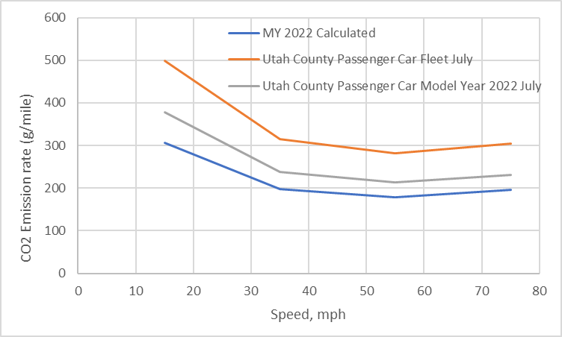

There should be two line, a calculated value for MY 2022, and a fleet average.

I added a third (middle line) which is the MY 2022 output from my MOVES run.

Note: that I conducted my MOVES run in July, due to air conditioning usage, the energy usage, and the CO2 emission rate is higher than the baseline emission rates used in the calculated MY 22 rate.

How do they compare? Does the difference in the model year 2022 and fleet-average CO2 g/mile make sense? Why?

The fleet average CO2 is higher than the 2022 model year. This is because new vehicles are more fuel efficient due to fuel economy standards.

The shape of the emission rates with respect to speed is the same for the older and new vehicles.

5 pts

1. The Northern Wasatch Front (“all or part of Salt Lake, Davis, Weber, and Tooele counties”[1]) has been designated as a non-attainment area of the National Ambient Air Quality Standards for ozone.

Ground-level ozone (O3) is formed from the reaction of Nitrogen oxides (NOx) and volatile organic compounds (VOC) in sunlight.

* 1. Using MOVES, estimate the total mass of NOx and VOC emissions (in kilograms) from all vehicles for Salt Lake County for a weekday in July at 6 pm in 2022.

The total mass of VOC and NOx exhaust emissions (kg) from onroad vehicles are shown in the table below for the July 6 pm weekday scenario.

|  |  |  |  |  |  |  |  |  |  |  |
| --- | --- | --- | --- | --- | --- | --- | --- | --- | --- | --- |
|  | NOx | | | | | VOC | | | | |
| Fuel | 2022 | | 2030 | | % Change | 2022 | | 2030 | | % Change |
|  | kg | % | kg | % | % | kg | % | kg | % | % |
| Gasoline | 414.8 | 41% | 135.9 | 24% | -67% | 166.7 | 84% | 85.54 | 84% | -49% |
| Diesel Fuel | 600.2 | 59% | 438.3 | 76% | -27% | 30.6 | 15% | 14.23 | 14% | -54% |
| CNG | 2.6 | 0% | 2.4 | 0% | -8% | 1.3 | 1% | 1.84 | 2% | 37% |
| E85 | 0.3 | 0% | 0.2 | 0% | -38% | 0.2 | 0% | 0.10 | 0% | -33% |
| Total | 1017.9 | 100% | 576.7 | 100% | -43% | 198.8 | 100% | 101.71 | 100% | -49% |

10 pts

What percentage of NOx and VOC emissions are from gasoline vehicles and from diesel vehicles?

10 pts

Percentage of VOC and NOx exhaust emissions from Gasoline and Diesel vehicles are shown below for the July 6 pm weekday scenario.

|  |  |  |  |  |  |  |  |  |  |  |
| --- | --- | --- | --- | --- | --- | --- | --- | --- | --- | --- |
|  | NOx | | | | | VOC | | | | |
| Fuel | 2022 | | 2030 | | % Change | 2022 | | 2030 | | % Change |
|  | kg | % | kg | % | % | kg | % | kg | % | % |
| Gasoline | 414.8 | 41% | 135.9 | 24% | -67% | 166.7 | 84% | 85.54 | 84% | -49% |
| Diesel Fuel | 600.2 | 59% | 438.3 | 76% | -27% | 30.6 | 15% | 14.23 | 14% | -54% |
| CNG | 2.6 | 0% | 2.4 | 0% | -8% | 1.3 | 1% | 1.84 | 2% | 37% |
| E85 | 0.3 | 0% | 0.2 | 0% | -38% | 0.2 | 0% | 0.10 | 0% | -33% |
| Total | 1017.9 | 100% | 576.7 | 100% | -43% | 198.8 | 100% | 101.71 | 100% | -49% |

Note: Select Default Scale, Inventory

For 2.2, you will need output by Fuel Type and Model Year in the ‘Output Emissions Detail’

Because MOVES takes a long time to run at default and county scale ☹, just include the exhaust processes (running exhaust, crankcase running exhaust, start exhaust, crankcase start exhaust, extended idle exhaust, crankcase extended idle exhaust, and auxiliary power exhaust). Ignore the evaporative processes and refueling processes for this exercise, however which they are important sources of VOC.

* 1. The US EPA set much lower NOx emissions standards for heavy-duty diesel trucks starting in model year 2010. Estimate the percentage contribution of NOx emissions from model year 2009 and earlier trucks to the NOx emitted from diesel vehicles in Salt Lake in 2022.

Are the pre-2010 trucks still a significant source of NOx emissions?

NOx emissions (kg)

|  |  |  |  |  |
| --- | --- | --- | --- | --- |
|  | Gasoline | Diesel Fuel | Compressed Natural Gas (CNG) | Ethanol (E-85) |
| pre-2010 = | 330.04 | 250.23 | 1.17 | 0.10 |
| total = | 414.85 | 600.25 | 2.56 | 0.27 |
| % old = | 80% | 42% | 46% | 39% |

Yes, they are still an important source of emissions. Using the default inputs of MOVES, 42% of diesel NOx emissions are estimated to come from 2009 and older diesel vehicles.

10 pts

* 1. The EPA will set a new deadline for Utah to comply with the ozone standard. If they do not demonstrate attainment by the deadline, then the EPA will require the Utah Division of Air Quality to impose more restrictive requirements on industry and vehicle sources in the Northern Wasatch Front.[2] Using MOVES, estimate the emissions of NOx and VOC from Salt Lake County for the same month, day type, and hour for calendar year 2030.

What is the percent reduction in the total vehicle NOx and VOC emissions in Salt Lake County modeled using MOVES between 2022 and 2030?

**43% decrease in NOx, and 49% decrease in VOC between 2022 and 2030**

10 pts

|  |  |  |  |  |  |  |  |  |  |  |
| --- | --- | --- | --- | --- | --- | --- | --- | --- | --- | --- |
|  | NOx | | | | | VOC | | | | |
| Fuel | 2022 | | 2030 | | % Change | 2022 | | 2030 | | % Change |
|  | kg | % | kg | % | % | kg | % | kg | % | % |
| Gasoline | 414.8 | 41% | 135.9 | 24% | -67% | 166.7 | 84% | 85.54 | 84% | -49% |
| Diesel Fuel | 600.2 | 59% | 438.3 | 76% | -27% | 30.6 | 15% | 14.23 | 14% | -54% |
| CNG | 2.6 | 0% | 2.4 | 0% | -8% | 1.3 | 1% | 1.84 | 2% | 37% |
| E85 | 0.3 | 0% | 0.2 | 0% | -38% | 0.2 | 0% | 0.10 | 0% | -33% |
| Total | 1017.9 | 100% | 576.7 | 100% | -43% | 198.8 | 100% | 101.71 | 100% | -49% |

What is the share of NOx and VOC emissions between gasoline and diesel vehicles in 2030? Is there an appreciable change in the share from diesel vehicles compared to 2022?

**NOx**

In 2022 the gasoline/diesel split for NOx is 41%/59%. In 2030, the gasoline/diesel split for NOx is 24%/76%.

NOx emissions decrease NOx emissions between 2022 and 2030 for both gasoline and diesel, but there are larger % decreases in emissions from gasoline vehicles as shown in the figure below.

**Yes, there is an appreciable change in the contribution of diesel in future years, with diesel projected to contribute a larger share of the NOx emissions.**

**VOC**

In 2022 the gasoline/diesel split for VOC emissions is 84%/15%. In 2030, the gasoline/diesel split for VOC is hardly unchanged at 84%/15%. VOC tailpipe emissions from gasoline and diesel vehicle decrease by ~ 50% between 2022 and 2030.

**For VOC, there is not an appreciable change in the diesel contribution to VOCs in 2030 compared to 2022.**

**Note the VOC emissions in our MOVES runs do not include evaporative or refueling emissions, which are dominated by gasoline vehicles. These trends may not hold for total VOC when those emissions are included.

10 pts

[1] Utah Division of Air Quality, “Ozone Overview and Standard Moderate Area Ozone SIP,” *Utah Department of Environmental Quality*, Aug. 12, 2020. https://deq.utah.gov/air-quality/ozone-overview-and-standard-moderate-area-ozone-sip (accessed Sep. 28, 2022).

[2] “Federal Register/Vol. 87, No.71. p. 21842-21858,” Apr. 13, 2022. https://www.govinfo.gov/content/pkg/FR-2022-04-13/pdf/2022-07513.pdf#page=1 (accessed Sep. 28, 2022).